§
Introduction
- Detail Billing Record - provides both financial data and non-financial billing detail used to create Pegasys billing transactions and ultimately bill the customer for the goods or services provided.
- Detail Billing Records can be received from external feeder systems or created manually and are used to create Billing Documents (BD) and Internal Vouchers (NV), summarizing “like” data records into documents and accounting lines
- The Detail Billing Record Query allows users to search for, manually enter, and edit existing Detail Billing Records
- Users can either enter Detail Billing Records from scratch, or, copy existing records and alter the information as needed
- Records added from the Detail Billing Record Query are considered non-associated as they have yet to be formally linked with a Pegasys transaction (a Billing Document (BD) or Internal Voucher (NV) form or document)
- Fields with red asterisks (*) are mandatory for Pegasys processes, but may not include all fields required by GSA policy.
- For detailed information, please refer to BAAR User Guide section 4.2, Detail Billing Records from Detail Billing Record Query.

Creating a DBR via DBR Query
- Log into Pegasys.
- Select Queries—Accounts Receivable— Detail Billing Record from the menu bar.
- The Detail Billing Record Query page will be displayed.
- Select New.
- The Accounting Elements (Detail Record Values) Page will be displayed.
- Enter the Record Date, System ID and any optional fields.
The System ID should be either FLEETMANL (for Fleet) or RENTMANL (for Rent).
- If creating a non-IPAC or interfund DBR, set the Bill Type dropdown to NULL. If creating an IPAC DBR, set the Bill Type drop down to IPAC.
- If creating an IPAC DBR, populate the Source Number field with the value of the OA number.
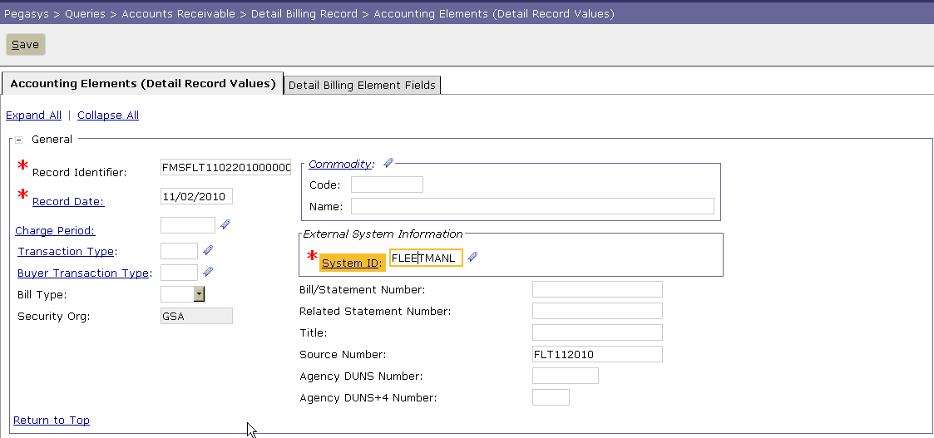
- Enter (or search using the reference link) the BOAC or Agency/Bureau (AB) in the Vendor Code field.
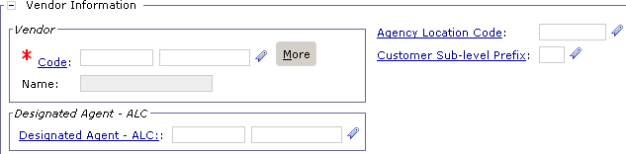
- Enter the Amount of the DBR.
- Enter the Quantity of the DBR. (Both Fleet/Rent will use the Quantity of 1.).
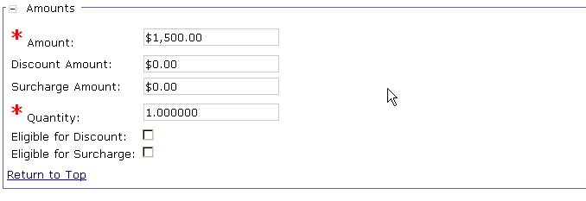
- Enter the Document Reference and Accounting Line for the DBR (this is the IX document for the interfund transaction.).
- Enter the Accounting Template and required Accounting Dimensions. (If using Accounting Template search, please refer to User guide for specific instruction)
Note: When searching for accounting templates, list the office code flanked by asterisk ("*FLT*" or "*RNT*") in the Accounting Template Description field.
- Select the Default button after entering the Accounting template to populate the accounting dimensions from the template.
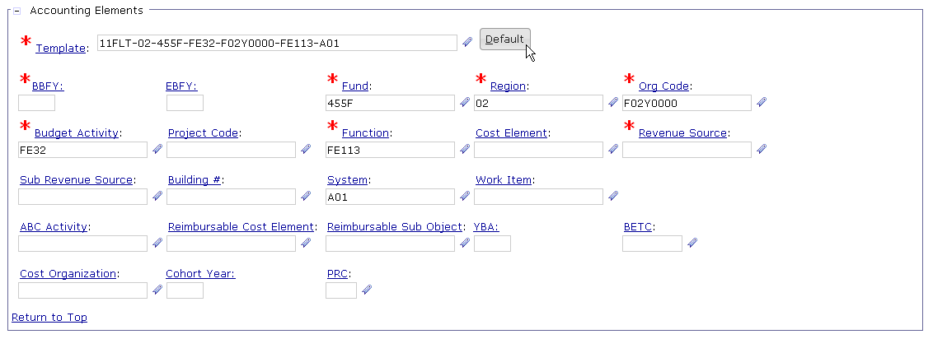
- Enter the Revenue Source Code. For Rent, enter Building Number.
- If creating an interfund DBR, populate the fields in the Accounting Elements – Buyer Side – Interfund Only group box:
- Accounting Template: To search for Buyer Side Templates use BOAC and Fedcode for fleet
- Enter any remaining accounting dimensions for the Buyer side such as Cost Element
- If creating an IPAC DBR, set the Funding Authorization Source to Funding Document in the Inter-Agency Transfer section. Enter Customer Funding Source, FSN, Accounting Classification Code, Unit Price, Unit, and Articles or Services.
- For RENT DBR – Enter the OA number in the Source Number and Funding Document fields.
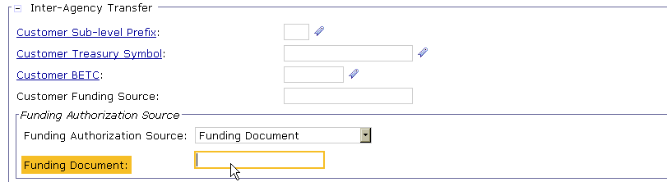
- Enter the Description information in the Credit Memo field if the DBR is a credit.
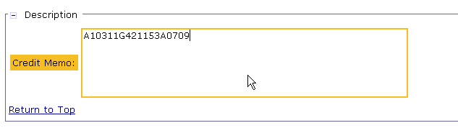
- Select the Detail Billing Element Fields tab.
- Enter Credit/Adjustment Indicator if the Detail Billing Record is a Credit (“C” for negative amounts) or Adjustment (“A” for positive amounts).
- Enter the DBE Period of Performance Start and End Dates.
- Enter the Interfund Indicator. See user guide for correct entry values.
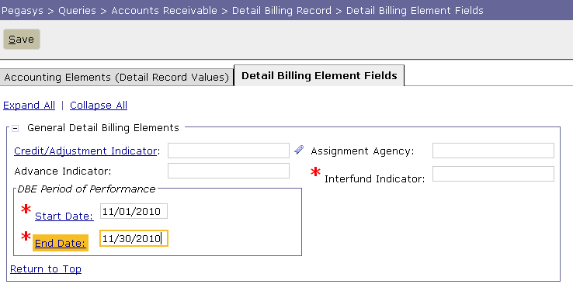
- Enter the required detail billing elements specific to the business line the DBR is being created for (Fleet or Rent).
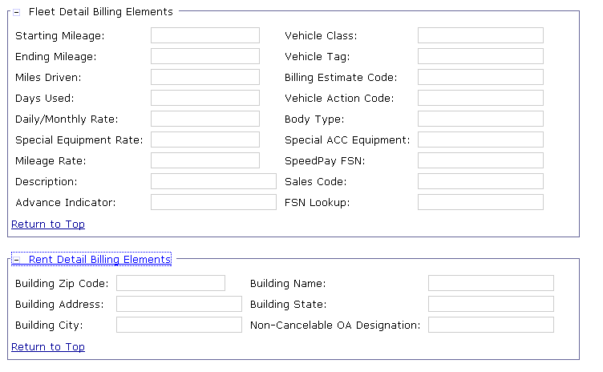
- For FLEET DBR only – Enter Sales Code.
- For FLEET Military DBR only –FSN Lookup value of F.
- For RENT DBR only – Enter the Non-Cancelable OA Designation as T or F.
- Select Save.
If no errors are encountered upon clicking the Save button, a message appears stating that the record has been saved successfully.

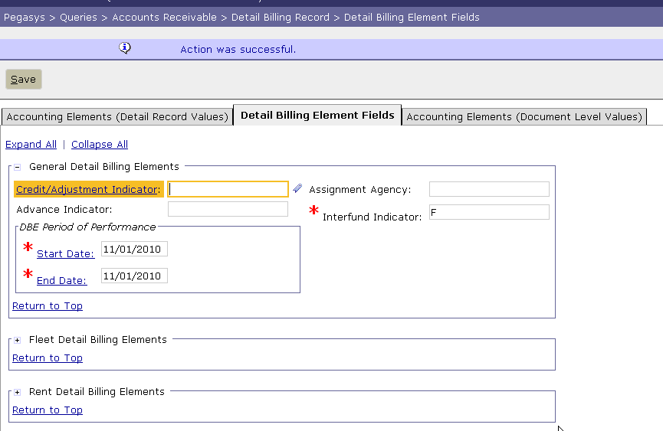

Pegasys Resources
- Functional Coordinator
- Service Representative
- Pegasys Web Site
http://pegasys.gsa.gov
- Pegasys User Guides
- BAAR User Guides
- Quick Reference Cards
- OCFO Consolidated Service Desk
1-866-740-0994


General
Services
Administration
The Integrated Financial Management System
March 2006 rev.1
Jan 2009 rev. 1
Pegasys 6.5.0: Creating
Detail Billing Records
Quick Reference
Card

